Project Update: Ultrasound bladder volume estimation.

This is how far we have gone, in the development of a semi-automated system to estimate the bladder volume by ultrasound images. The overall aim of this project is to manipulate raw ultrasound screenshots, localize the scan regions of interest, extract important anatomical data, and calculate bladder volume via a clinically validated equation.

In the first place, we were interested in the organization of the ultrasound data. Every image usually has a two-view; a transverse view to measure length and width and a sagittal view to measure depth. Besides these, the pictures also include several UI components like headers, side panels, and annotations, that add noise and makes it hard to analyze them directly. One of the earliest challenges to accomplish was to identify and eliminate these irrelevant regions.

To address this, we adopted an automatic Region of Interest (ROI) detection algorithm. This was done by color-based filtering to remove the blue UI elements and intensity thresholding to remove dark background areas. The detected regions were refined by morphological operations like closing and opening. Lastly, the connected component analysis was used to locate the two biggest objects on the image which were the two ultrasound images. These areas were then aggregated to create a bounding box that only covers the area of the scan that is of interest.

Once the ROI was extracted additional refinements were made to enhance the accuracy of ROI. The upper part of the header and the side UI panels were deleted and slight margins were provided such that the entire bladder area was covered. This created a narrow rectangular space which is very close to the size of the real scan area, as desired.

The following step was to automatically divide the ROI into left and right views. This was done by identifying the difference between the two ultrasound panels and finding a split position according to the midpoint of the difference. The left is the transverse view and the right is the sagittal view. This separation is critical because the measurement of various dimensions of the bladder is done using each of the views.

An interactive annotation system was subsequently created to elicit measurements. The user can use mouse clicks to select points on the images: two pairs of points on the left image to measure length and width, and one pair of points on the right image to measure depth. These distances (based on pixels) are then translated into real-life units with the help of a calibration method.

Lastly, the ellipsoid approximation formula is used to calculate the volume of the bladder: Volume = 0.52 × Length × Width × Height. The formula has found extensive clinical application and is a reasonable estimate of bladder volume. The present implementation yields results that are near anticipated clinical values.

Altogether, we have managed to create a functioning pipeline that is able to take an ultrasound image as an input, identify and extract the necessary area, divide it into suitable views, extract measurements, and calculate the volume of the bladder. Though the system has to be manually fed with the measurements at the moment, it provides a great basis to be further automated in the future.

The following directions are to enhance pixel calibration, strengthen ROI detection when using diverse datasets, and transition to fully automated pixel measurement extraction using image processing, or deep learning models. Finally, a fully automated and clinically reliable bladder volume estimation system is to be developed.

-Sample Image :
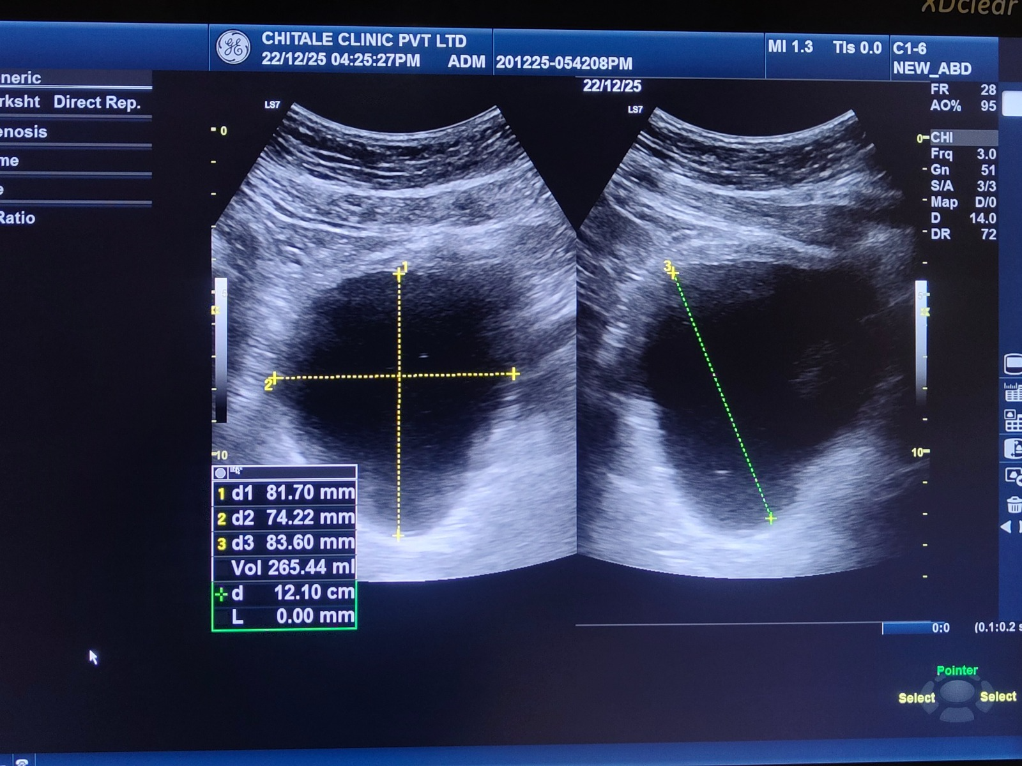

This is the input image that we have.

-Extracted area:
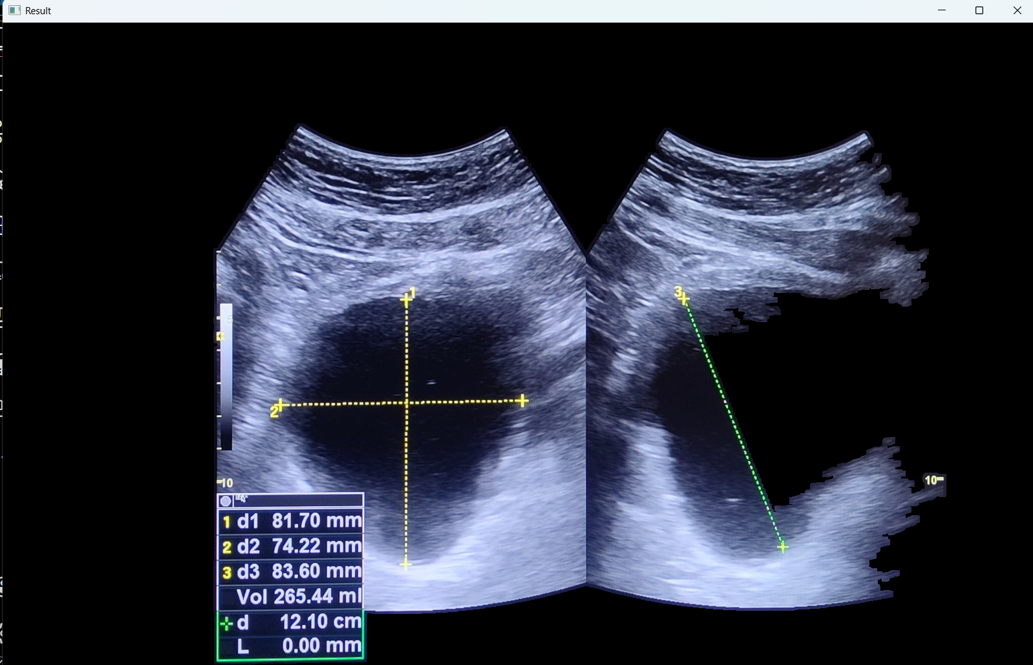

The split view :
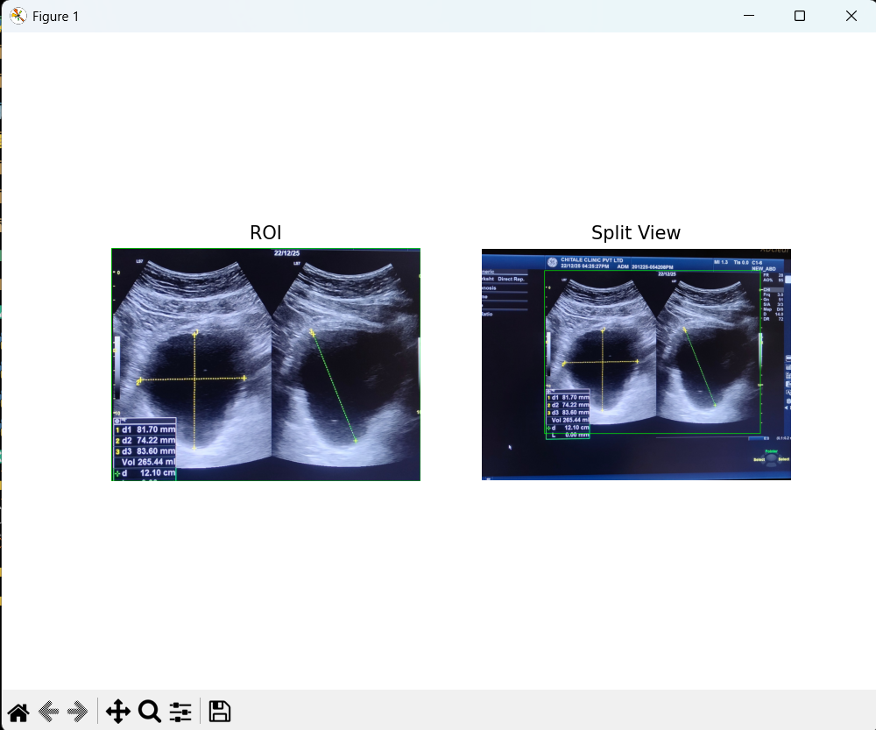

The left view :
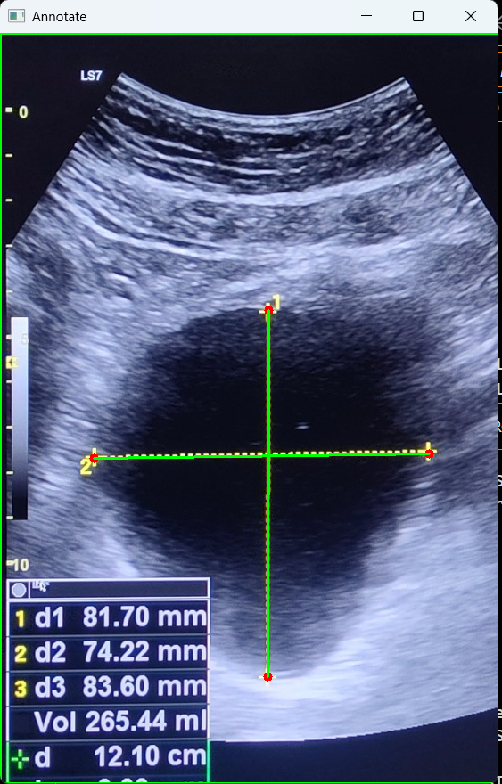

The right view :
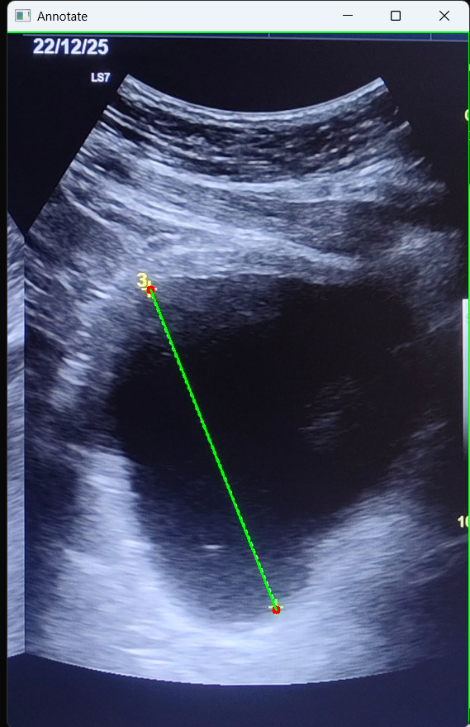
The result parameters that we got :
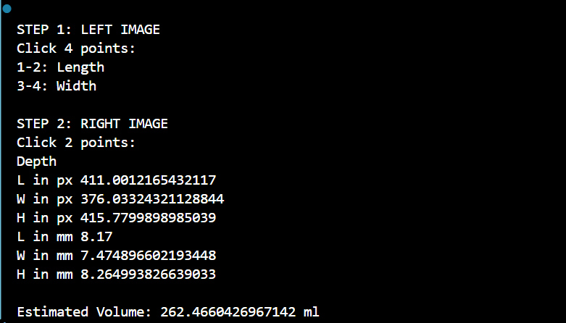

Here the originally calculated volume as per input image is : 265.44
The estimated volume that we got is : 262.46

